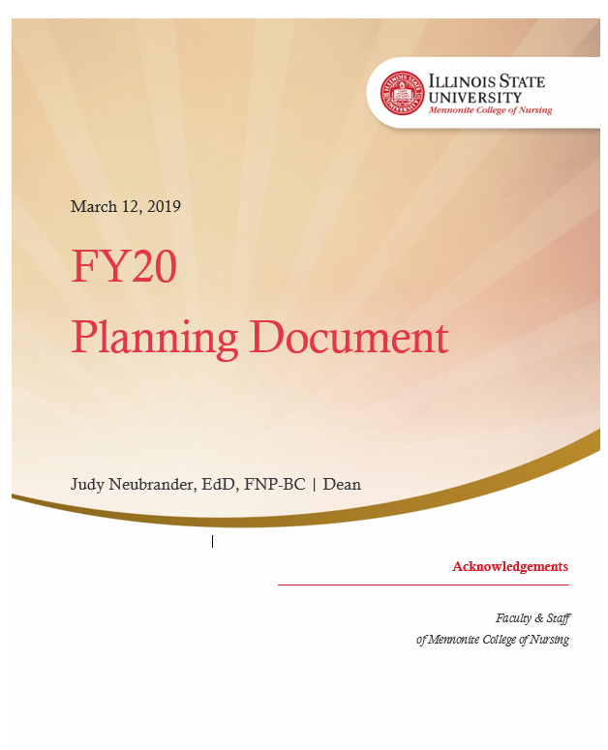

Table of Contents



Mission Statement 3

Vision Statement 3

**Strategic Goals …………………………………………………………………………………………………………………… 4**

**Strategic Map …………………………………………………………………………………….……………………………… 5**

Major Objectives for FY20 6

Illinois State University’s

Mennonite College

of Nursing

# Mission Statement

Mennonite College of Nursing promotes excellence and innovation in education while striving to improve health locally and globally through exceptionally well-prepared nurses.

# Vision Statement

The vision of Mennonite College of Nursing is to be a community that sets the standard for excellence in nursing practice and education, changing the world one exceptionally well-prepared nurse at a time.

Mennonite College of Nursing Strategic Goal Alignment with Educate • Connect • Elevate: Illinois State

|  |  |  |  |  |  |
| --- | --- | --- | --- | --- | --- |
| **2018 – 2023**  **Educate, Connect, Elevate** | **MCN Strategic Goal 1:**  Teaching Our Students with Excellence | **MCN Strategic Goal 2:**  Strategically Grow Research and Scholarly Works | **MCN Strategic Goal 3:**  Collaborate with Our Community | **MCN Strategic Goal 4:**  Develop Diverse Clinical Experiences for Our Students | **MCN Strategic Goal 5:**  Grow and Promote a Premier Institution of Nursing Excellence |
| **ECE Goal 1:**  **Enhance Strength and Stability** |  |  |  |  |  |
| **ECE Goal 2:**  **Foster Innovation** |  |  |  |  |  |
| **ECE Goal 3:**  **Nurture Diversity and Inclusion** |  |  |  |  |  |
| **ECE Goal 4:**  **Enrich Engagement** |  |  |  |  |  |

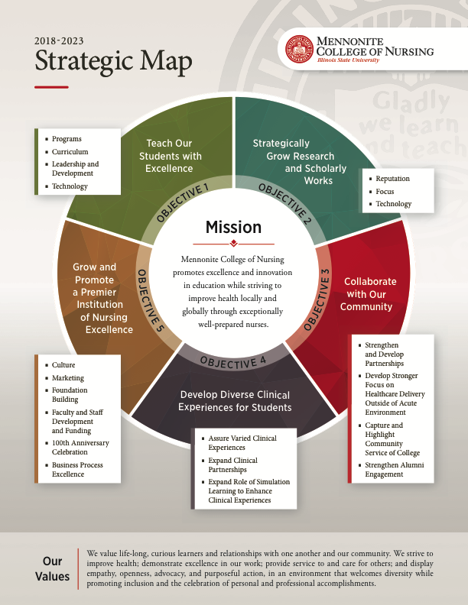

­­

# Major Objectives for FY20

Below is an outline of college goals represented in the Mennonite College of Nursing 2018-2023 Strategic Plan. Those goals completed in the prior fiscal year are designated as completed, while others listed as a focal point for FY20 are listed as such. Goals to be addressed beyond FY20 and those that are on-going each year, though strategic, are also designated.

*See page 13 for guide to the abbreviations of committee and roles responsible for overseeing these goals.*

|  |
| --- |
| **Strategic Goal 1: Teach Our Students with Excellence**Objective 1: Programs  * (Future goal) Goal 1: Plan, manage and explore growth of new and current programs (responsible: PCC, RN BSN, GPCC)  Objective 2: Curriculum ­ Goal 1: Holistic review and adjustment of undergraduate and graduate curricula; align to identified best practices, industry needs, licensure requirements, and accrediting agencies (responsible: PCC, RN BSN, GPCC)  Goal 2: Integrate holistic health, vulnerable populations, cross-disciplinary experiences, and service into clinical experiences that align with curricula (responsible: PCC, RN BSN, GPCC)   * (Ongoing) Goal 3: Integrate and utilize simulation learning experiences to enable greater clinical competence (responsible: SC)   ­Goal 4: Align testing with NCLEX standards throughout undergraduate program (responsible: PCC)   * (Ongoing) Goal 5: Maintain standards of excellence using benchmark data, aspirant schools and NCLEX pass rates (responsible: ADA)   Objective 3: Leadership & Development  Goal 1: Integrate leadership development, service concepts, and work environment expectations into curriculum where appropriate (responsible: PCC, RN BSN, GPCC)   * (Future goal) Goal 2: Explore strategic campus-wide partnerships – MBA Program; Public Health; (completed MBA analysis FY19) (future goal: Public Health) * (Ongoing) Goal 3: Conduct Leadership Academy (responsible: Dean)   + Provide students with the knowledge, experience and exposure necessary to successfully navigate the business environment of healthcare   Goal 4: Provide support and learning opportunities for gender-specific challenges potentially facing our male and female students (responsible: PCC, RN BSN, GPCC)  Objective 4: Technology   * (Future goal) Goal 1: Explore new technologies--virtual reality, robotics, telehealth, etc. * (Ongoing) Goal 2: Further develop online learning offerings, distant education and methods to promote and support these offerings (responsible: PCC, RN BSN, GPCC) * (Future goal) Goal 3: Further expand simulations learning; explore online simulation   Goal 4: Develop digital testing- online testing platform (responsible: PCC) |

|  |
| --- |
| **Strategic Goal 2: Strategically Grow Research and Scholarly Works**  Objective 1: Reputation   * (Ongoing) Goal 1: Hire faculty with competence and motivation to achieve desired quality and quantity of research; assess needs and impending retirements of current faculty (responsible: DC) * (Future goal) Goal 2: Consider faculty member for NIH Reviewer Training * (Future goal) Goal 3: Increase quantity and quality of externally funded research, projects, and publications; engage faculty on focus area that are fundable   Goal 4: Increase number of research presentations both locally, nationally, and internationally (responsible: ADR, CRC)   * (Future goal) Goal 5: Using marketing strategies, develop alternative communication channels on research outcomes for internal and external audiences   Objective 2: Focus  Goal 1: Define Research Focuses for College – diverse populations, vulnerable people, cross discipline, clinical practice (responsible: ADR, CRC)   * (Future goal) Goal 2: Balance funded and unfunded research * (Ongoing) Goal 3: Hire and sustain tenure track faculty that support research focus (responsible: DC)   Objective 3: Technology   * (Ongoing) Goal 1: Leverage technology to enhance programs that require research- PhD, DNP, etc. (responsible: ADR, CRC) * (Complete FY19) Goal 2: Support large dataset studies * (Complete FY19) Goal 3: Develop simple and transparent tracking system for timelines on grant submissions, IRB protocol submissions, all current research projects – especially ones that are happening with our students |

|  |
| --- |
| **Strategic Goal 3: Collaborate with Our Community**  Objective 1: Strengthen & Develop Partnerships   * (Ongoing) Goal 1: Explore health-related opportunities that help to educate our students and provide a benefit to the community – both on and off campus (responsible: APSP, ANEW, CAUSE)   Goal 2: Offer health-related service experiences through cross-agency collaboration that develop leadership skills, and understanding of vulnerable and diverse populations (responsible: APSP, ANEW, CAUSE, SEL)  Objective 2: Develop Stronger Focus on Healthcare Delivery Outside of Acute Environment   * (Ongoing) Goal 1: Ensure curriculum teaches nursing's role in community health, public health, wellness/prevention, primary health care, end of life, ambulatory centers, and other non-hospital based care (responsible: PCC, RN BSN, GPCC) * (Ongoing) Goal 2: Lead community health, wellness, and prevention events in partnership with other community organizations -- focus skill development on leadership, communication, project management, teamwork, cross discipline knowledge/collaboration, public speaking, and education (responsible: APSP)   Objective 3: Capture and Highlight Community Service of College  Goal 1: Ensure nurse's role and responsibility in serving others is taught in curriculum and track faculty, staff, and student service work (responsible: ADA)   * (Complete FY19) Goal 2: Assess and track all service projects and work being done today and maintain data * (Ongoing) Goal 3: Highlight health-related service work by college in branding stories about the college (responsible: DMR) * (Ongoing) Goal 4: Target and strive for meaningful change through focused service work (responsible: TBD)   Objective 4: Strengthen Alumni Engagement  Goal 1: Engage alumni in focus areas such as fund raising, developing clinical sites, collaborating on community service projects, assisting in classroom or simulation lab learning, and mentoring students in clinical settings and alumni relations (responsible: Dean) |

|  |
| --- |
| **Strategic Goal 4: Develop Diverse Clinical Experiences for Students**  Objective 1: Assure Varied Clinical Experiences   * (Future goal) Goal 1: Offer experiences in diverse settings that align to industry shifts–outpatient and ambulatory environments, in-patient environments, mental health, chemical dependency, long-term care, end of life care, chronic disease care, and global health–assuring nursing students understand clinical practices beyond the traditional in-patient medical model * (Future goal) Goal 2: Develop simulation situations in environments beyond acute care for both undergraduate and graduate students.   Objective 2: Expand Clinical Partnerships  Goal 1: Expand partnerships beyond inpatient acute care settings, partner with other health-related organizations (health department, cancer clinic, hospice, long-term care settings, etc.), assure cross disciplinary/multi-disciplinary experiences (responsible: DUP, DGP)  Objective 3: Expand Role of Simulation Learning to Enhance Clinical Experiences   * (Ongoing) Goal 1: Utilize simulation to complement coursework, expand research and publication opportunities, and model clinical best practice (responsible: SC)   Goal 2: Expand faculty simulation expertise to promote quality student simulation-based learning opportunities (responsible: SC)  Goal 3: Explore additional spaces and opportunities to expand simulation programs (responsible: SC) |

|  |
| --- |
| **Strategic Goal 5: Grow and Promote a Premier  Institution of Nursing Excellence**  Objective 1: Culture   * (Ongoing) Goal 1: Provide and communicate clear and simple job responsibilities for roles (responsible: DC)   Goal 2: Assess culture and job satisfaction through faculty and staff engagement. Target areas for improvements (responsible: Culture Committee led by 1 CC Chair)   * (Future goal) Goal 3: Develop stronger faculty/staff connections and utilization * (Ongoing) Goal 4: Hire faculty and staff that align to culture and College’s needs (responsible: DC)   Goal 5: Consciously develop the culture elements that are meaningful; develop, foster, and hold people accountable to expected cultural norms (responsible: Culture Committee led by 1 CC Chair)  Goal 6: Assess and consider purpose and outcomes of all meetings;  improve efficiency and effectiveness of meetings to decrease frequency of meetings (responsible: DC, Committee Chairs)  Objective 2: Marketing   * (Ongoing) Goal 1: Curate and leverage content that illustrates MCN’s value and nurtures relationships with students, community, and industry (responsible: DMR)   + Use research excellence as a tool for attracting students and faculty; especially focusing on programs where growth is needed and beneficial to the college   + (Completed FY19) Design, document, and implement a marketing and recruitment plan that is SMART (Specific, Measurable, Achievable, Relevant, and Time-bound) * (Future goal) Goal 2: Recruit high caliber and diverse students, faculty, and staff   Goal 3: Increase brand awareness, perception, and affinity within Illinois;  then expand beyond state (responsible: DMR)   * (Ongoing) Goal 4: Leverage technology and marketing automation (responsible: DMR)  Objective 3: Foundation Building Goal 1: New Facility (responsible: Dean)   * + Create a vision for the building and begin planning   + Communicate and inspire the community, alumni, and donors with the possibilities   + Begin seeking commitments of financial support * Goal 2: Funding and Financial Security (responsible: Dean)   + (Ongoing) Grow scholarships for students, faculty, and staff   + (Ongoing) Seek novel and creative funding sources and solutions for the College   Review funding allocations for IT and Marketing given strategic intentions  Track annual funding from research grants Objective 4: Faculty Outreach  * (Ongoing) Goal 1: Increase awareness of expertise internally to guest lecture in class or offer faculty development and externally to support outreach, partnership and reputation (responsible: ADA) * (Future goal) Goal 2: Provide annual education event for nurses, community agencies, and other partners   Objective 5: Faculty and Staff Development and Funding   * (Ongoing) Goal 1: Assess needs and deliver development to faculty and staff (responsible: DC)   Goal 2: Develop succession plans (responsible: DC)  Goal 3: Redefine and implement a faculty mentoring program (responsible: ADA)  Objective 6: 100th Anniversary Celebration   * (Complete FY19) Goal 1: Plan for celebration using opportunity to engage community, alumni, faculty, staff and students * (Complete FY19) Goal 2: Consider goals of Capital Campaign and link with anniversary celebration   Objective 7: Business Process Excellence  Goal 1: Data   * + Assess and refine data to better understand finances, performance, growth, and other meaningful outcomes (e.g. enrollment, application, retention, diversity) (responsible: AD-AS, BPE committee)   Goal 2: Processes   * + Assess and improve MCN business processes for streamlining, automation, and reporting accuracy (responsible: AD-AS, BPE committee)   + Assess current systems for accuracy, and usefulness, and leverage automation for report generation (responsible: AD-AS, BPE committee)   + Assess job duties and reduce overlap and redundancies (responsible: DC)   Goal 3: Reporting (responsible: AD-AS and BPE committee)   * + Identify MCN Scorecard with Key Performance Indicators   + Assess reporting needs – seek automation, simplicity and transparency   + Standardize reporting and report delivery |

|  |  |
| --- | --- |
| **Abbreviation** | **Committee / Role** |
| ADA | Associate Dean for Academics |
| AD-AS | Associate Dean for Academic Support |
| ANEW | Advanced Nursing Education Workforce |
| APSP | America’s Promise School Project |
| BPE | Business Process Excellence |
| CAUSE | Change Agents for the Underserved: Service Education |
| CC | College Council |
| CRC | College Research Committee |
| DC | Deans Council |
| DGP | Director of Graduate Program |
| DMR | Director of Marketing and Recruitment |
| DUP | Director of Undergraduate Program |
| GPCC | Graduate Program Curriculum Committee |
| PCC | Prelicensure Curriculum Committee |
| PROUD | Pre-entry and Retention Opportunities for Undergraduate Diversity |
| RN BSN | RN to BSN Curriculum and Program Committee |
| SC | Simulation Committee |
| SEL | Student Engagement Leader |
| TBD | To be determined |